**CST-361 Design Patterns in Java**

Student Name: Fredrick Onduso Ondieki

Project Title: Activity 3: Presentation Layer Patterns

Date: December 24, 2018

**Write ups**

This project illustrates the development of web applications using presentation pattern. Secondly, the project created here follows the MVC design pattern where there is a Model, Controller and View. The model handles all the business logic for instance the user and login classes for the user. The controller acts as a mediator between the Controller and the views. The views in this project have the .xhtml extensions.

**Project structure**

**Screenshots**

The screenshots bellow shows the registration, login and validation properties incase a user does an illegal activity while attempting to register or login.

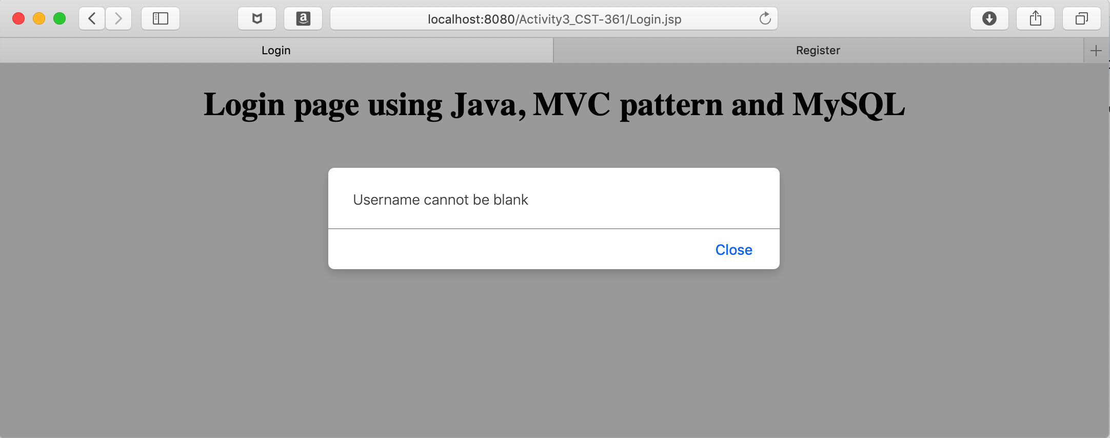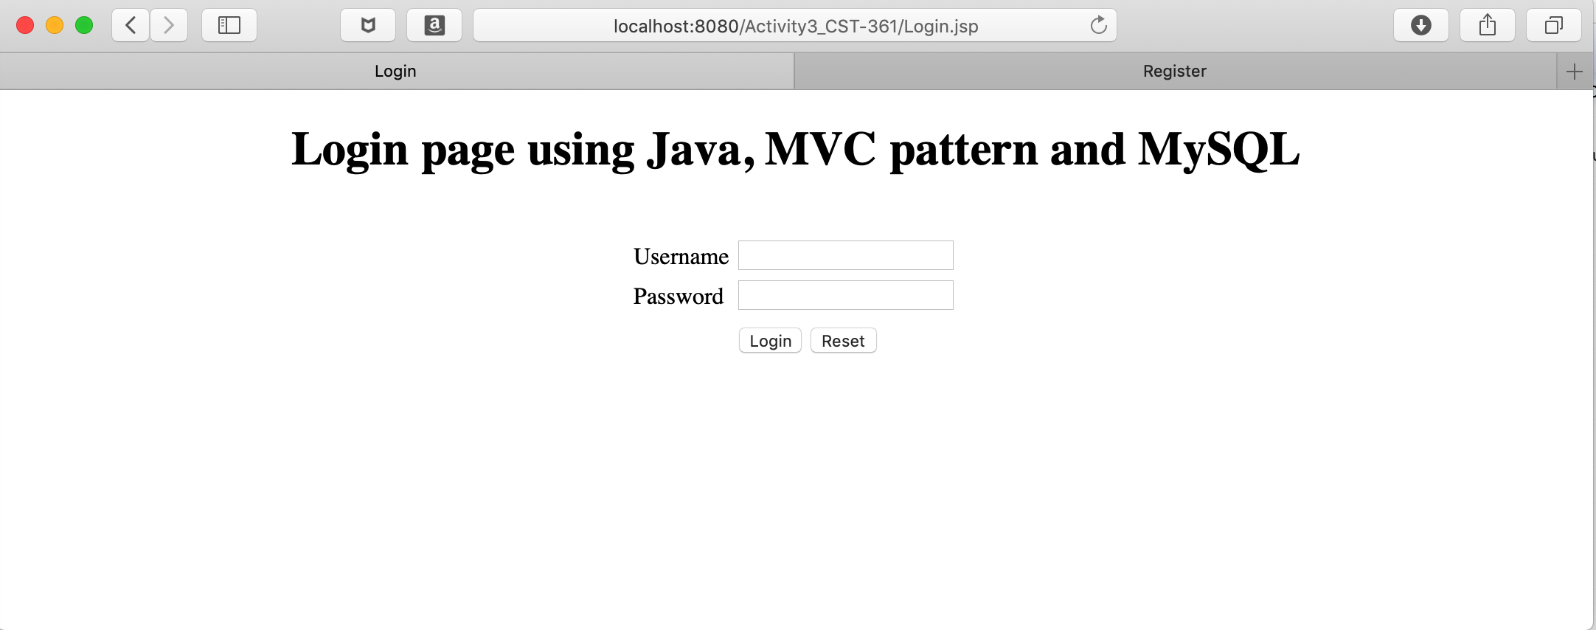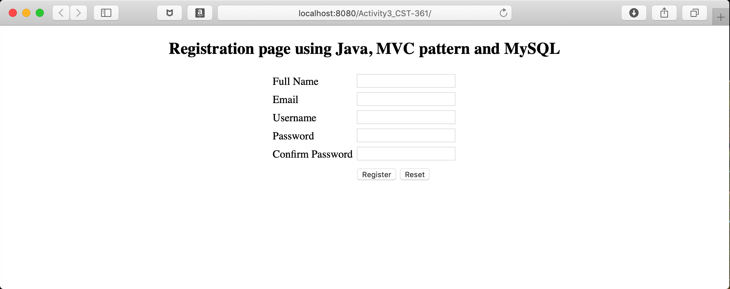

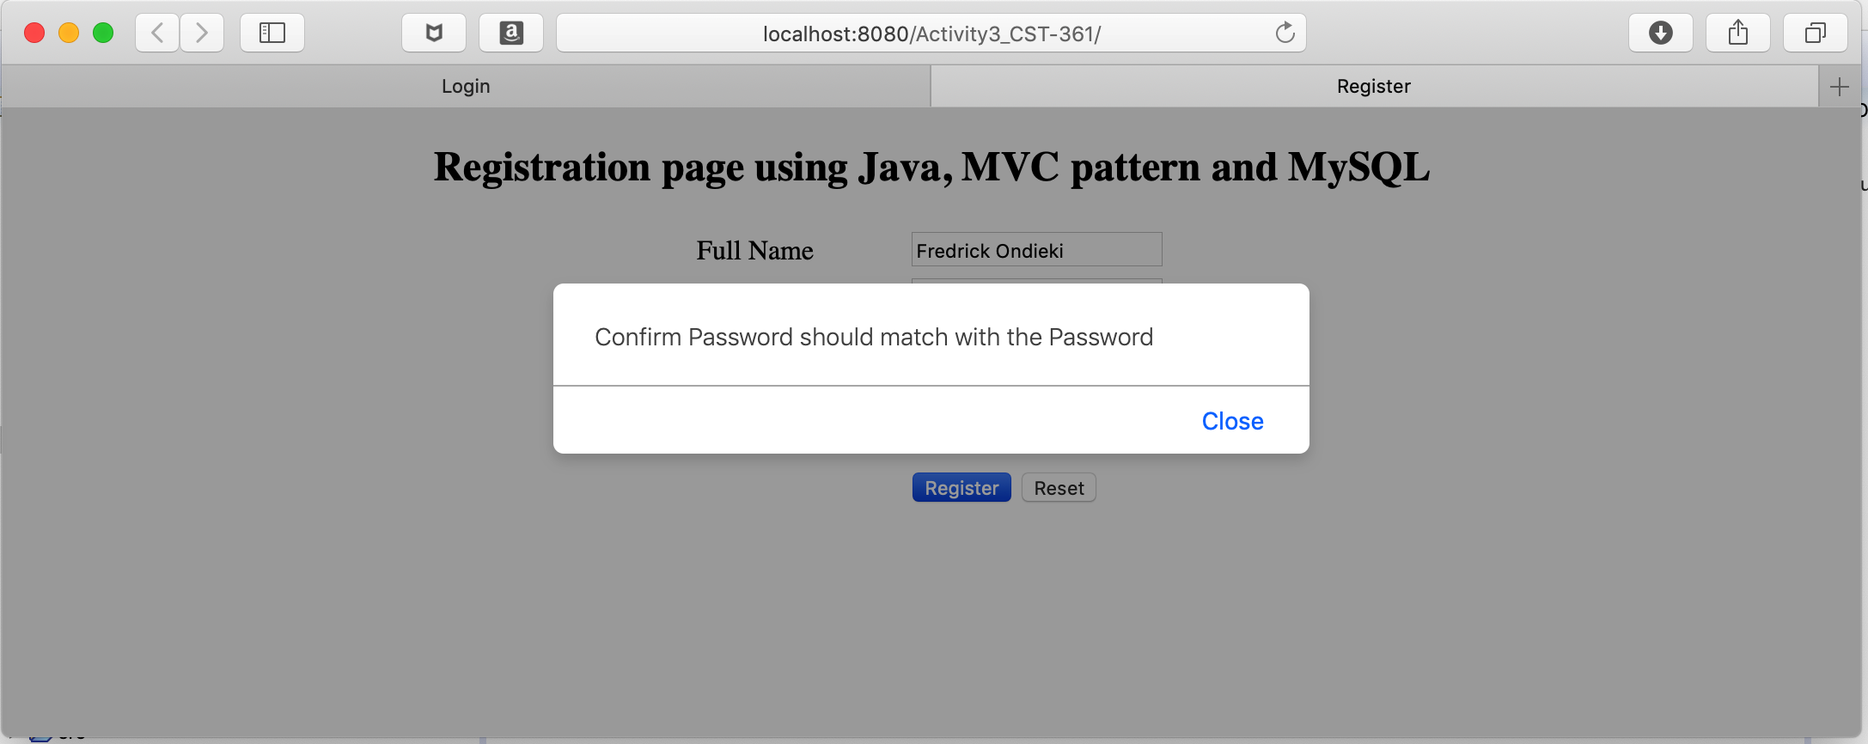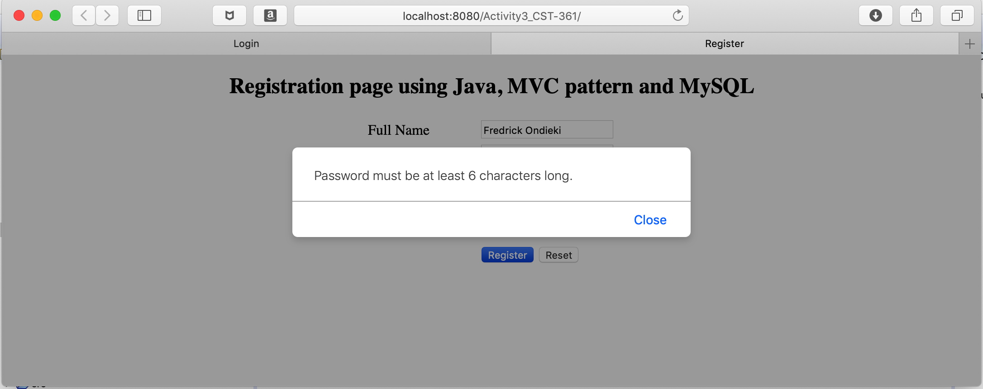

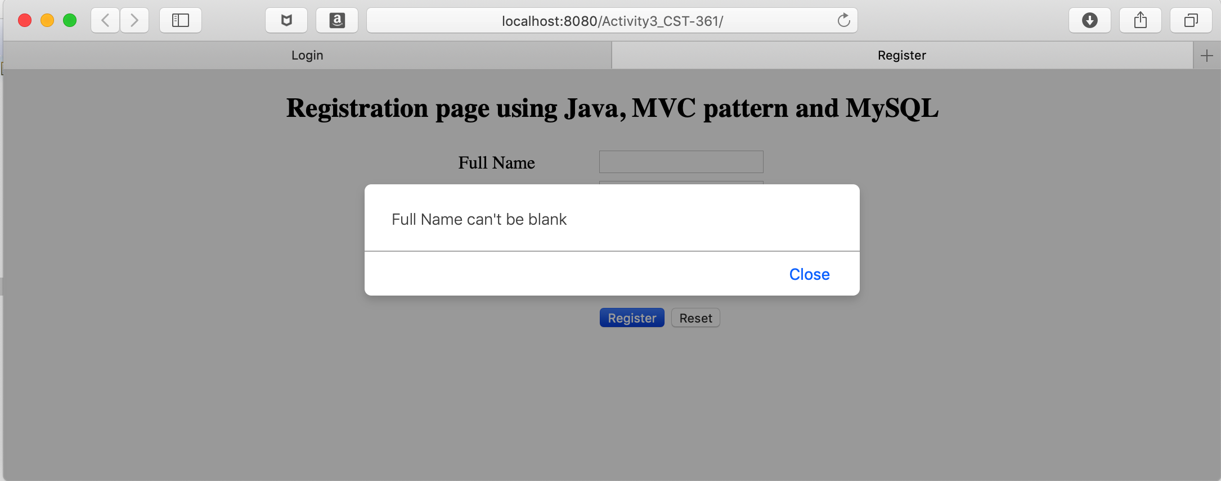

**What went well**

After a few hours of struggle I managed to get the project upto speed. I managed to create the JSF to be used in the project. Secondly, using JavaScript, I managed to set up the user validation rules to monitor user activities against leaving the text input fields empty or even entering “unwanted characters” on the fields.

**What did not go well**

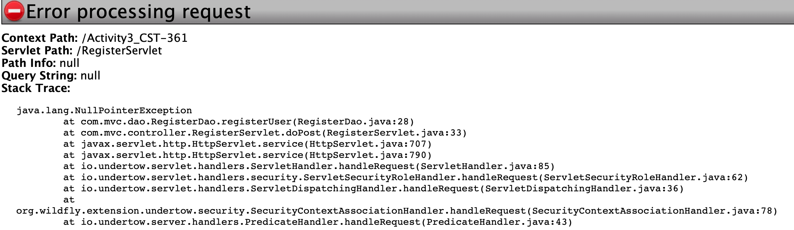After creating the project and the relevant files needed for the project, I failed successfully trying to register/login to the application. The screenshot bellow illustrates the kind of error that I got.

Source Code

The Source code for the application is uploaded to a github repository account accessed via

https://github.com/FREDDYSMALLZ/OnlineBookStore_CST-361